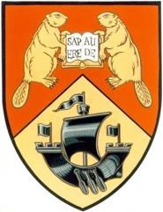
2018-19
University of New Brunswick
Law Students’ Society
General Election Information

The LSS will be holding an election on February 20th and 21st for the following positions:

LSS Executive
- President
- Vice-President
- Treasurer

Faculty Council
- 2L Faculty Council Representative
- 3L Faculty Council Representative

LSS Council
- 2L Council Representative (2)
- 3L Council Representative (2)

Election Rules:
- No campaign materials are to be posted to existing bulletin boards and not on painted surfaces.
- No campaign materials are to be posted in the Ludlow Hall lobby during polling periods.
- Candidates are prohibited from campaigning in any manner in the lobby during polling periods.

Failure to adhere to these rules may result in a disqualification from the election.

Dates to Remember:
- February 8th – Nominations open. Forms available in the LSS Lounge
- February 12th 11:30am –Mandatory Information Session
- February 12th 5:00pm – Nominations close. Forms can be dropped off in LSS Lounge or sent electronically tconnoll@unb.ca
  - Note: please send an email indicating a form has been dropped off to the LSS lounge.
- February 13th-20th – Campaign
- February 20th-21st – Voting will take place in Ludlow Hall lobby from 11:30 – 1:00pm.

Contact:

Tanisha Connolly
Chair & CRO, LSS
tconnoll@unb.ca

